**LetsUpgrade AWS Essentials Day4**

**Project3**

Instances: Linux1

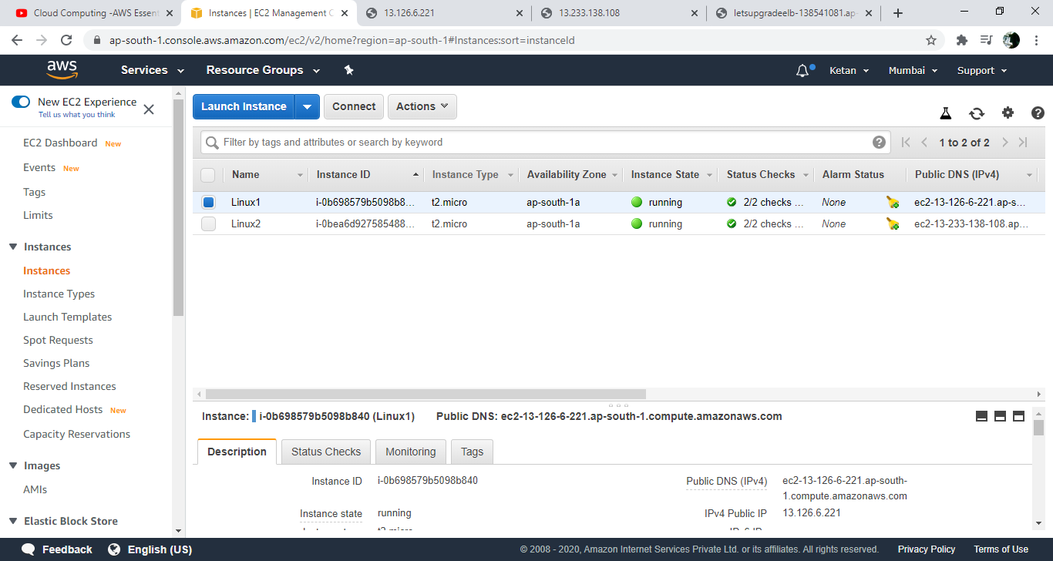

Instances: Linux2

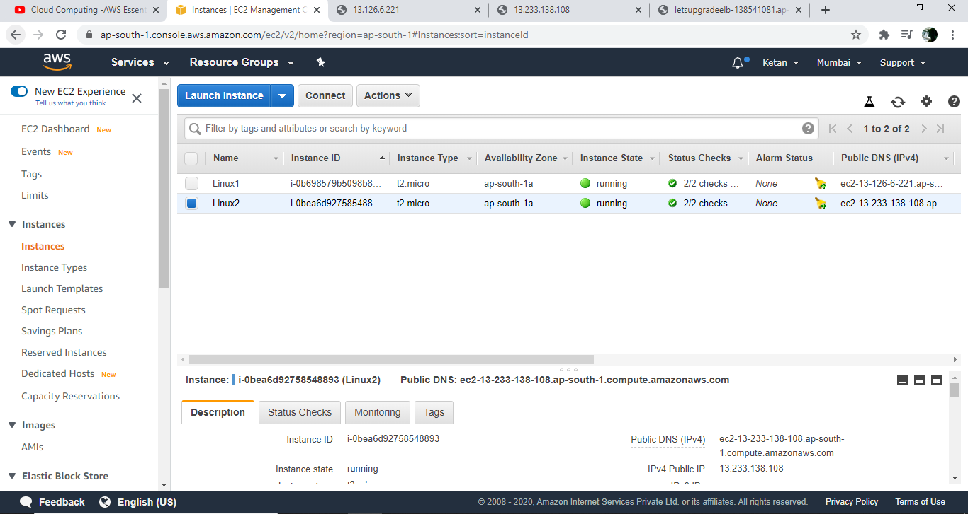

Linux1:

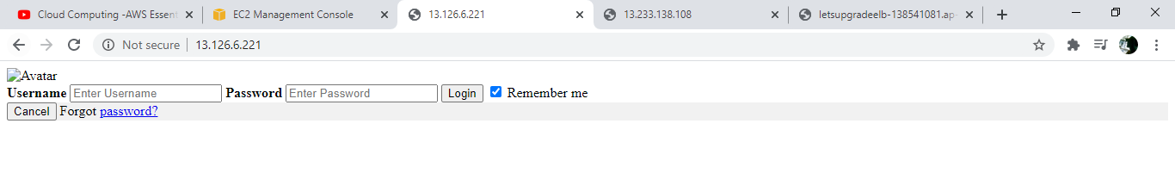

Linux2:

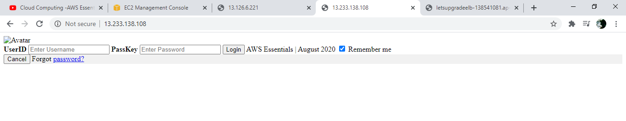

Load Balancer:

